**Designated Survivor Season 4: Release Date and other details!** 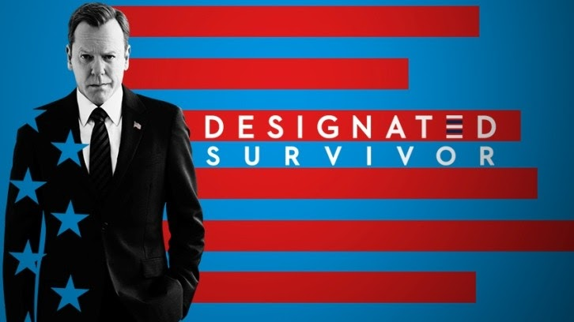

***Designated Survivor***, an American Political and conspiracy thriller and drama created by David Guggenheim for **ABC** (Seasons 1-2) and **Netflix** (Season 3 worldwide; Seasons 1-2 outside North America). It's one of the highest viewed shows with over 10 million views on its ***season*** 1 release.

**Designated Survivor Season 4: Release Date**

The show was formally publicized on May 6, 2016. Then the first episode was released on September 21, 2016, with viewers of over 10 million. After 8 days of the ***release*** of the first episode of season 1, a complete season in progress was announced. Then on May 11, 2017, the *series* was renewed for ***Season*** 2 which was released on September 27, 2017. In May 2018, the series got canceled by ABC. But later in September 2018, ***Netflix*** and ***Entertainment One*** announced their deal to pick up ***Designated Survivor*** for Season 3 with 10 episodes. ***Season*** 3 streamed on June 7, 2019, on ***Netflix***. Then the show was ***canceled*** in July 2019 by ***Netflix*** because of the actors' contract complications. Then a remake was made in South Korea with Ji Jin-hee as the lead actor. It was named Designated Survivor: 60 Days and was developed by Studio Dragon which streamed on tvN in South Korea and on ***Netflix*** worldwide from July 1, 2019, to August 20, 2019. Reasons were the complicated contracts of the actors that were distinct from the contracts for other television shows on *Netflix*. Additionally, Netflix didn't book many actors for Season 3 leading many actors to get busy in other shows and series. So, renewal of the show for ***Season 4*** seems to be very complicated unless everyone comprises and they're willing to do another season. But there's no official announcement on anything from the ***Netflix*** side that if they'll create another ***season***. They just announced that they'll keep on premiering Designated Survivor for three seasons.

**Designated Survivor Season 4: Expected Plot and Cast**

Even though the chances of revival of the show for ***Season 4*** seem to be deemed but still if anyhow it returns then it's likely to revolve around the lead actors and characters who appeared in three previous seasons. So, let's recap a few of them:

**Kiefer Sutherland** being ***Tom Kirkman***- He's the **U.S. president** sworn in following the death of the president and everyone in the line of succession in an unprecedented **attack** on the **Capitol building**. He was the Secretary of Housing and Urban Development before the crowned president. In later seasons he's elected as the president for a second term. He's involved in finding the reason and the person behind the attack on the Capitol building.

Natascha McElhone being Alex Kirkman- She's the First Lady of the United States. Before becoming First Lady, she was an exodus attorney in a particular practice. In Season 2, she's killed in a truck accident. 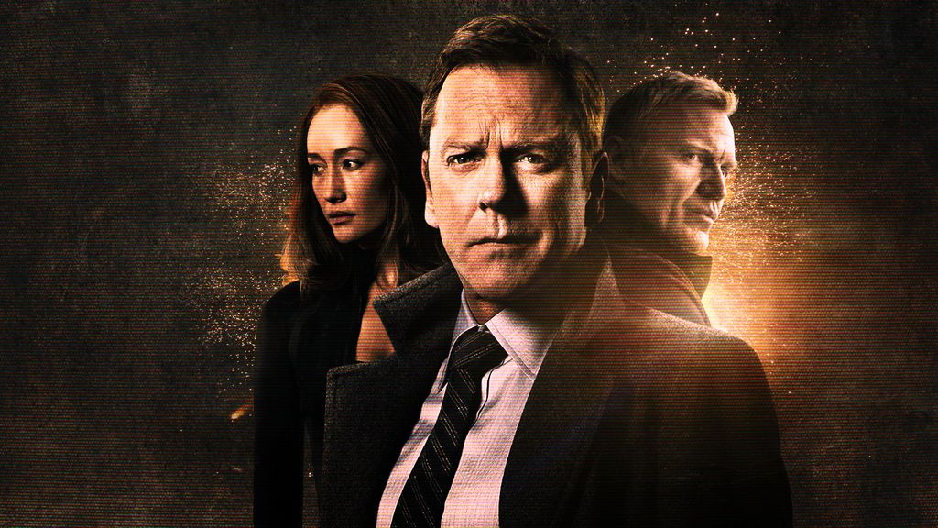

Adan Canto being Aaron Shore- He's the Vice President-elect of the United States. Before that, he worked as the Chief of Staff for Kirkman until he resigned because he was queried about the terrorist attack on the Capitol. Then he worked as a senior guide help to the Speaker of the house Kimble Hookstraten before he became Kirkman's National Security Advisor returning to the White House.

Italia Ricci being Emily Rhodes- she's the spokesperson of Kirkman's presidential campaign. She worked for Kirkman since he was HUD Secretary and she was designated as his Chief of Staff. When Kirkman became President, she was appointed to be his special advisor, then after Adan resigned, she took the charge of Chief of Staff until she returned to Florida to live with her mother. Later on, she returned and was reappointed as Special Advisor to Tom.

LaMonica Garrett being Mike Ritter- He's a secret service agent. He was assigned to Tom for personal protection. He was in charge of the protection of the whole Kirkman family after the Capitol attack.

Tanner Buchanan being *Leo Kirkman*- He's the son of Tom and Alex. He is assigned to take care of his younger sister Penny while his parents were busy with their new task. Later on, he moves to Stanford University for his freshman year.

Kal Penn being Seth Wright- He's the White House Communications Director. Initially, he doubts Tom for his skills as the president but later in the show he becomes one of his closest advisors. He was Press Secretary before his promotion to Communications Director. He has very strong social skills.

Maggie Q being *Hannah Wells*- She's a CIA Case Officer. She was before an FBI Special Agent, then she's assigned the task to investigate the attack on the Capitol building. She solves the attack case before being fired from the Bureau. Later on, she's involved in the investigation of a possible threat of bioterrorism for the CIA, which leads her to death.

And many others. So, as we saw the show is centered around the US President and his officials. So, if ***Season 4*** comes then it'll revolve around Tom Kirkman, his family, and his officials involved in solving different mysteries circling the US President and Capitol building.

**Designated Survivor Season 4: Trailer**

Since nothing has been confirmed by the creators and the distributor of the show regarding the ***release*** of ***Designated Survivor Season 4***, so there's no release of the ***trailer*** of the same. But you can enjoy the ***trailer*** of Season 3😊

https://www.youtube.com/watch?v=zTJbUVjS--M